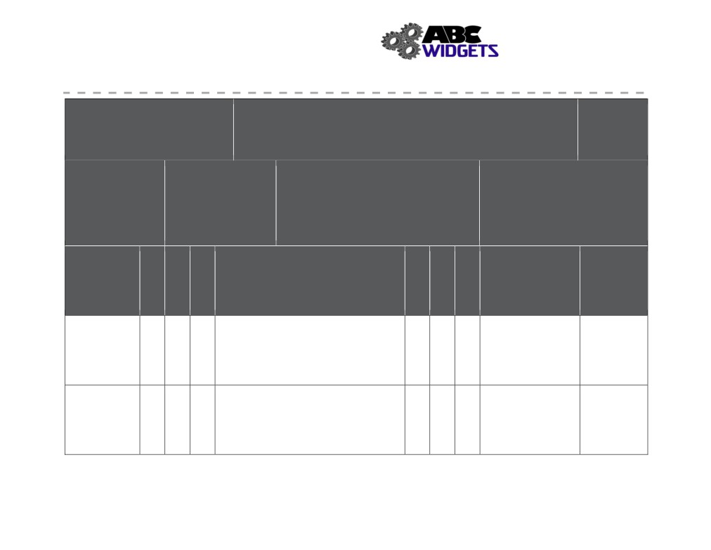

Health and Safety Manual
ABC Widget Oilfield Services Ltd. - FORMAL HAZARD ASSESSMENT

Task Assessed: Travelling -
passenger vehicle
Positions Considered: All positions

Assessment Team: (needs to include affected employee) FHA #: # 001
John Downy; Kris Marsh; Blake Edwards
Revision #: 1
Date: Nov. 1, 2018

Referenced Specialized PPE or
Legislation: Equipment:

tinted safety glasses

Hazards

Severity
1. Negligible/OK: Causing minor injury that requires first aid or
less
2. Minor: Causing non-serious injury, illness, or damage that re-
quires medical aid
3. Serious: Causing severe injury, serious illness, that is disabling
or lifelong, or property and equipment damage
4. Imminent danger: Causing death, widespread occupational ill-
ness, or loss of facilities

Probability
1. Extremely Remote: Unlikely to occur
2. Remote: Could occur at some point
3. Reasonably Probable: Likely to occur eventually
4. Probable: Likely to occur immediately or soon

Outstanding Expected

Associated with Existing Hazard Controls Implementation Completion
Task Assigned To Date

Unmanaged 4 3 12 Eng: 4 1 4 Jason to look into July 10, 2019
Work Schedule Admin: work-rest cycle impacts if we institute
(Fatigue) PPE: daylight driving only

Prolonged 2 3 6 Eng: 1 2 2
Seating Admin: work-rest cycle, ergonomic training,
ergonomic assessment
PPE:

111
Severity
Probability
Priority
Severity
Probability
Priority

Health and Safety Manual

Exposure to 4 3 12 Eng: 3 2 6 Jason to look into Jan 31, 2019
other Traffic Admin: lights, brakes, clean windows and all defensive driving
(collision) lights. training course
PPE: sunglasses

Poor Job Fit 2 1 2 Eng: 1 1 1
(stress) Admin: training, work-rest cycle
PPE:

Severe Weather 3 3 9 Eng: 2 1 2
Conditions Admin: proper tires, 4 wheel drive purchase
(loss of control) requirement, pre-trip weather report, well
maintained vehicle
PPE:

112

