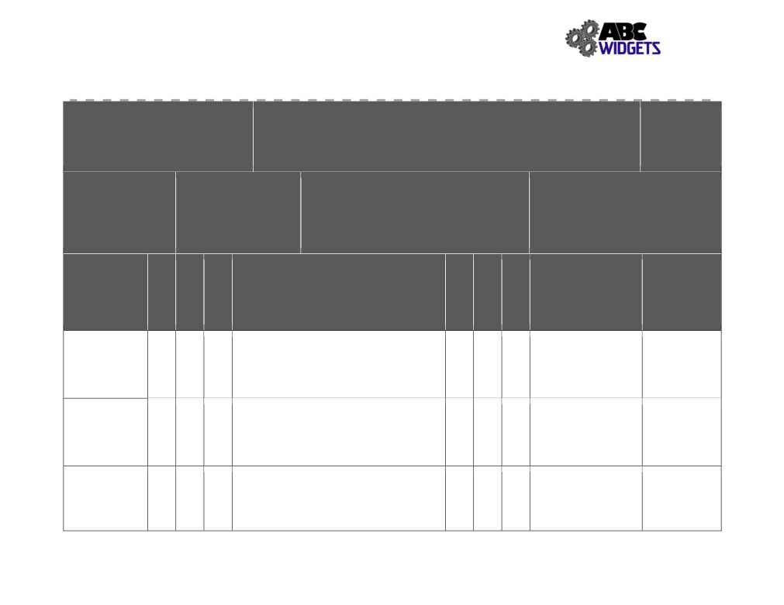

ABC Widget Oilfield Services Ltd. - FORMAL HAZARD ASSESSMENT

Task Assessed: Operate Forklift
Positions Considered: Shop Super, welder, machinist, Labourer

Assessment Team: (needs to include affected employee)
Arthur Curry, Sandra Bullox
Date: Nov. 1, 2018

1. Negligible/OK: Causing minor injury that requires first aid or
FHA #: # 008
Revision #: 1

1. Extremely Remote: Unlikely to occur

Referenced
Legislation:
OH&S Code: Part 19
-8 - Powered Mobile
Equipment

Hazards
Associated with
Task

Pinch Points
(hands/fingers)
4

Tipping Over

4

Exposure to
fumes
Specialized PPE or
less
Equipment: 2. Minor: Causing non-serious injury, illness, or damage that re-
quires medical aid
3. Serious: Causing severe injury, serious illness, that is disabling
or lifelong, or property and equipment damage
4. Imminent danger: Causing death, widespread occupational ill-
ness, or loss of facilities

Existing Hazard Controls

Eng: Roll cage
Admin: SJP # 008; Training, keeping hands
4 16 4 3 12
within roll cage
PPE:

Eng: Seat Belt, roll cage
Admin: SJP # 008; Trained Worker, speed
3 12 4 3 12
limit, housekeeping, compliance with mfg limits
PPE:
Eng: facility ventilation
Admin: SJP # 008; Training, operate with OH
2. Remote: Could occur at some point
3. Reasonably Probable: Likely to occur eventually
4. Probable: Likely to occur immediately or soon

Outstanding Expected
Implementation Completion
Assigned To Date

Look into air quality April 2019, Jon
monitors for shop and Downy

4 4 16
doors open.
PPE:
3 3 9
warehouse

127
Severity
Probability
Priority
Severity
Probability
Priority

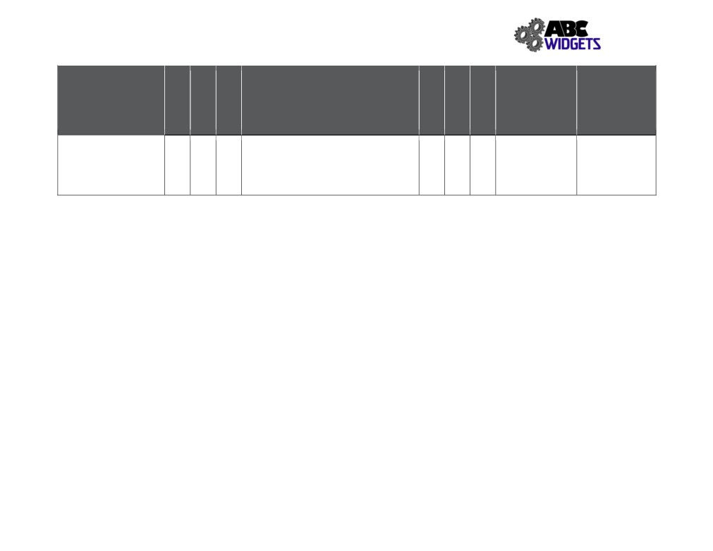

Hazards Associated with Task

Unintentional contact

4 4 16

Existing Hazard Controls

Eng: adequate facility lighting, roll cage Admin: SJP # 008; training, back-up
alarm, lights, PM service for lights and
brakes, speed limit

Outstanding
Implementation
Assigned To

4 3 12

Expected
Completion Date

128
Severity
Probability
Priority
Severity
Probability
Priority

